CHEX Learner Guide | This guide was designed exclusively for CHEX eLearning clients and contains detailed information on how to navigate through the system through the Learner role.

Table of Contents

Logging into CHEX Learning 3
Home 4
Training 14
Groups 18
Completing a Course from the Training Tab 19
Important Message about CE Modules 26
Curricula 27
Printing Certificates 29
CHEX Technical Specifications 35
Disable Pop-Up Blocker Instructions 35

Logging into CHEX eLearning

To log into the CHEX system through the Schoox App, launch the app from your phone’s homepage or app page. The Password is case-sensitive.

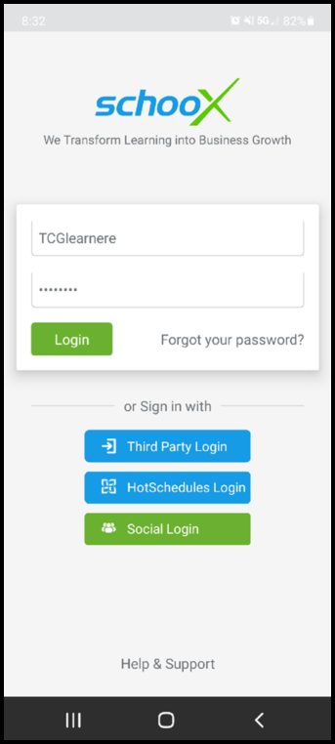

Search for the Schoox app in the Apple Store or Google Play Store depending on your phone type.

Home
Home – This is the learner’s landing page upon successfully logging into the app. It provides access to registrations, available material and notifications. You can return to this screen any time by clicking the 3 horizontal line menu in the top left corner

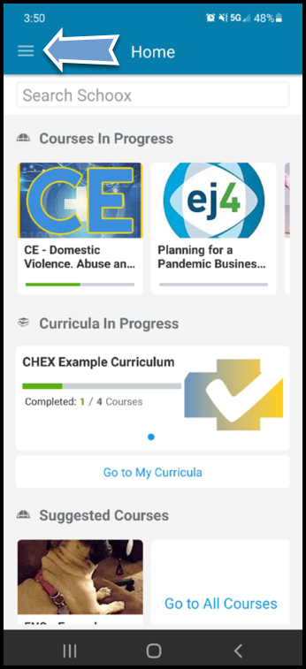
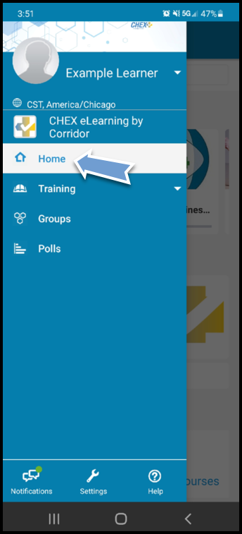

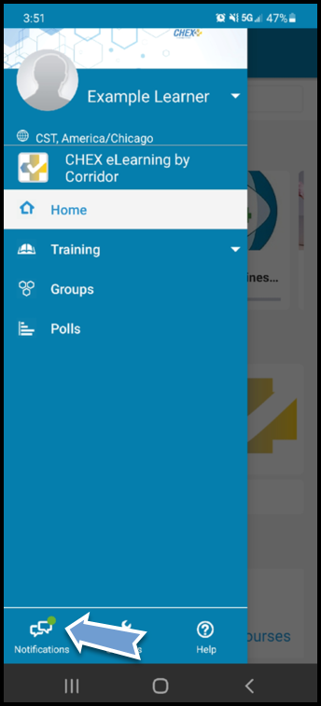
Notifications – This is where your system notifications will display
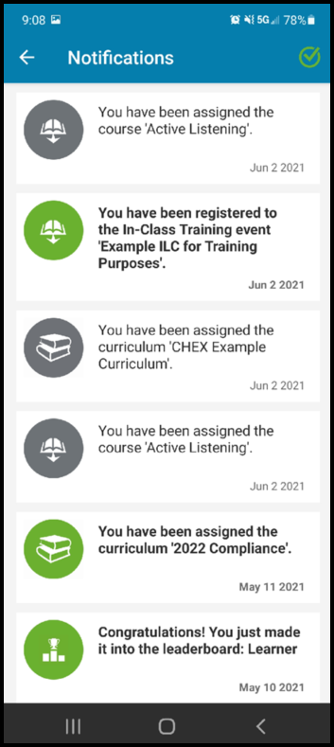

Settings – This link allows you to check and change your account settings in the app
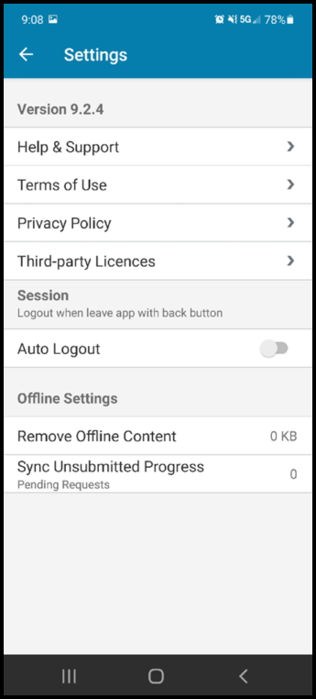
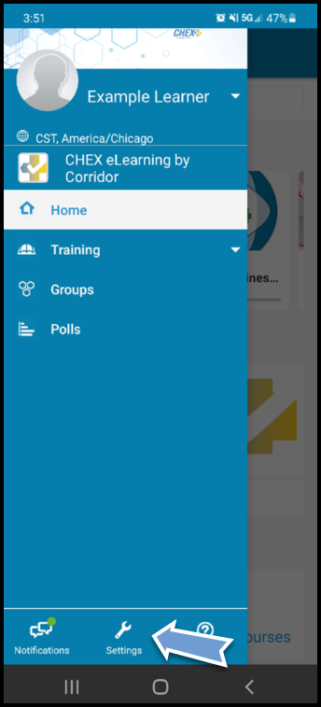

Account – This link allows you to access all aspects of your profile including certificiates, inbox messages, privacy settings, etc.

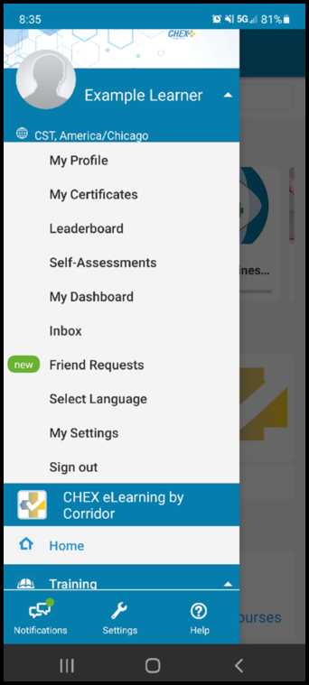
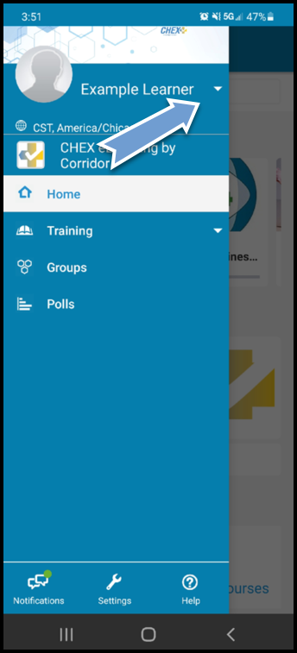

My Profile – This is where you can edit your profile and about information displayed in CHEX. Click the pen icon at the bottom right to make changes. Once complete, click the X icon at the bottom right
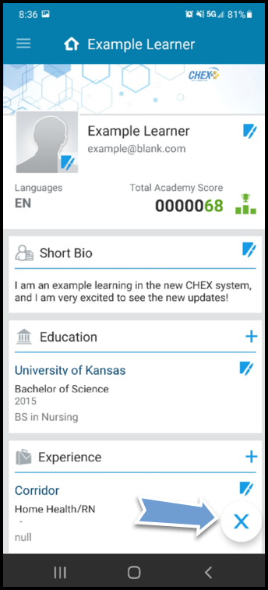
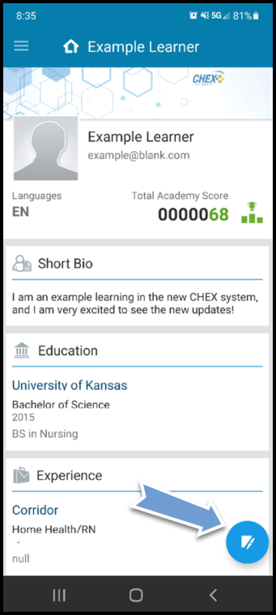
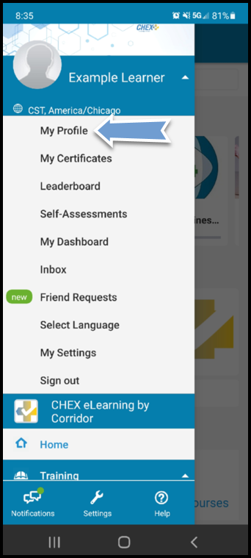

My Certificates – This link allows you to view and print certificates you have earned
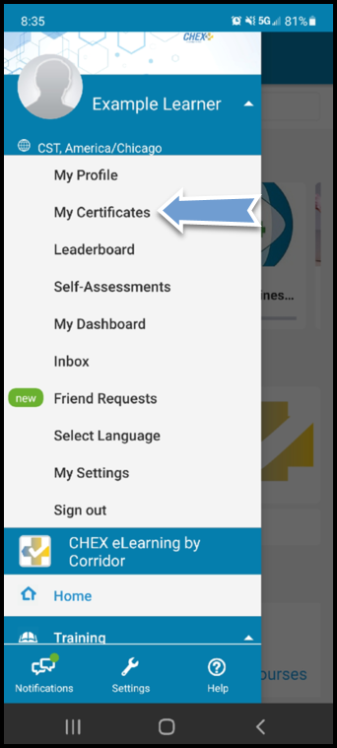
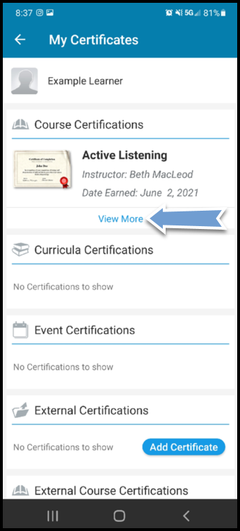
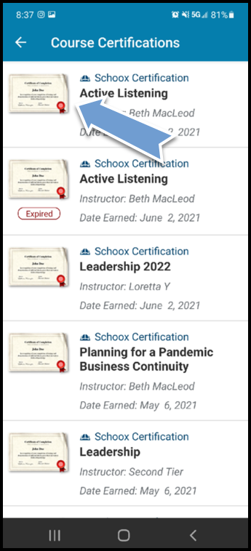

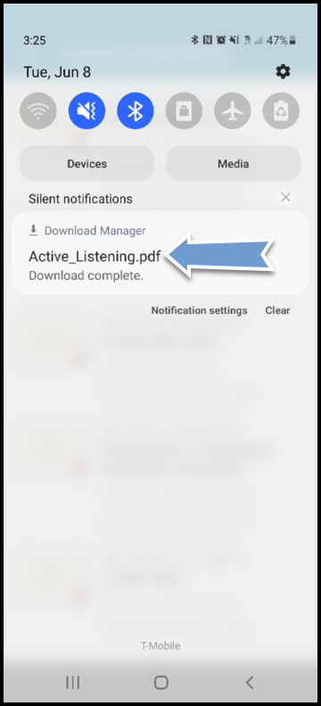
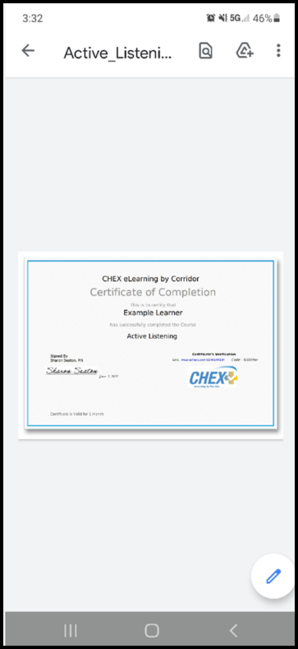
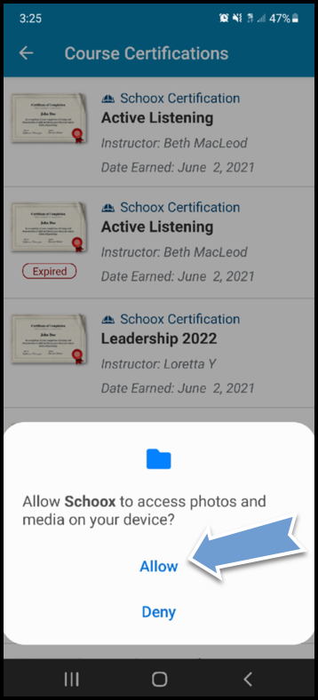

Leaderboard – This link will show you the system leaderboard for points earned in the system
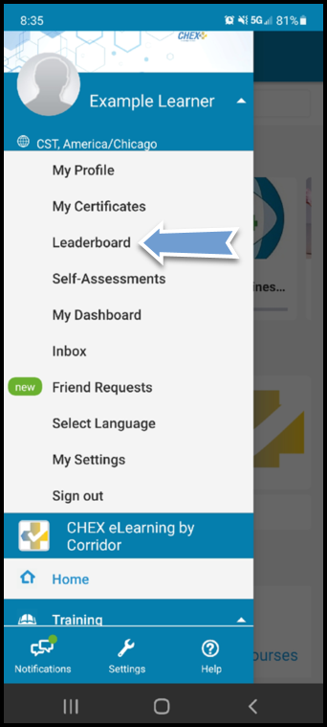

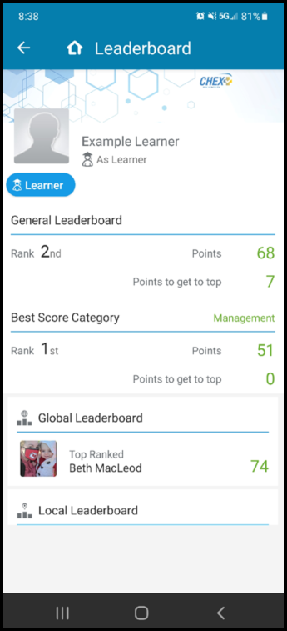

Self-Assessments – This link will allow you to view self-assessments available to complete
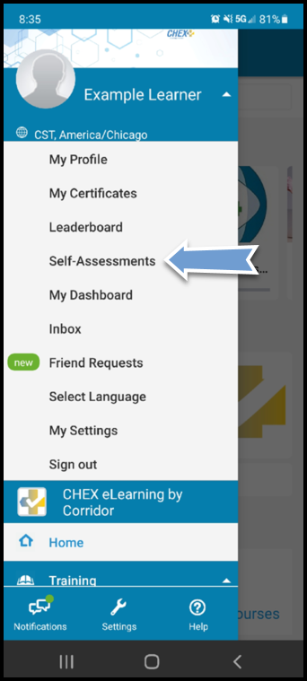

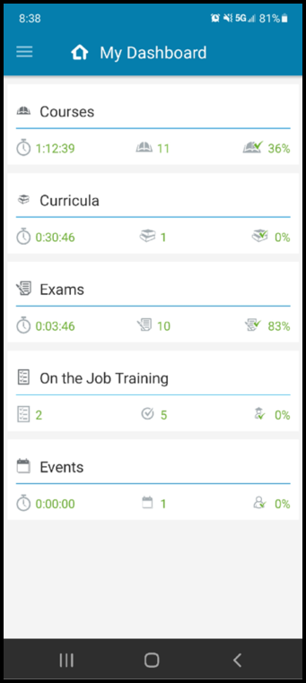
My Dashboard – This link shows a breakdown of enrollments and completions
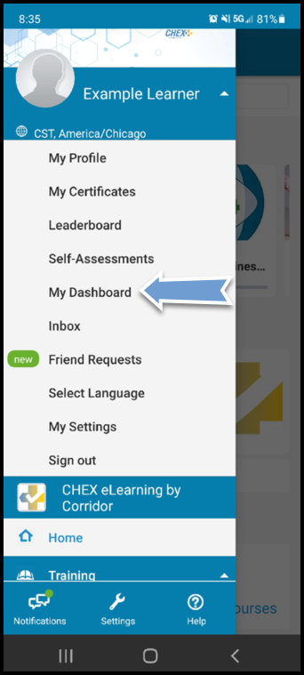

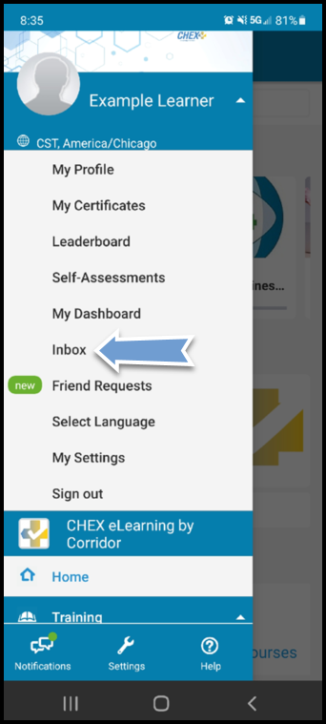
Inbox – This link allows you to view and send messages from your inbox

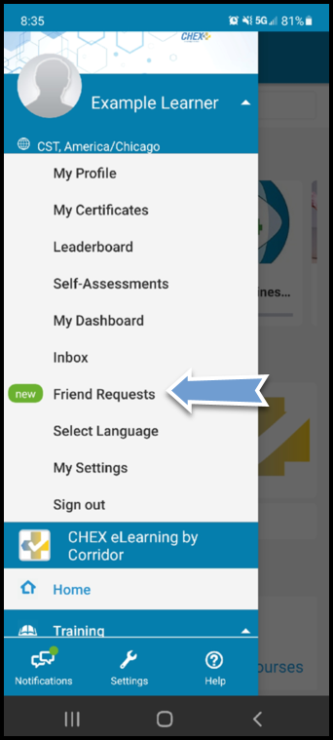
Friend Requests – This link allows you to view sent and received friend requests

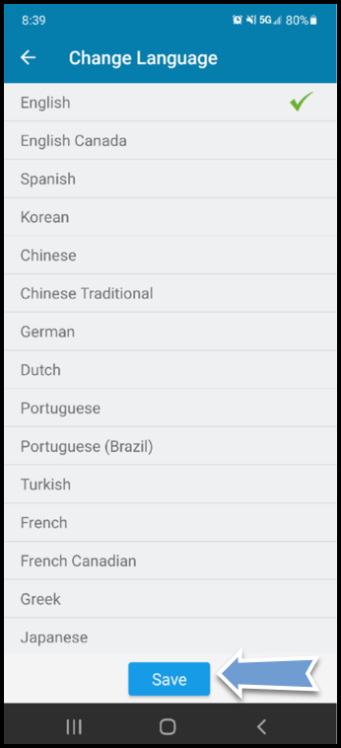
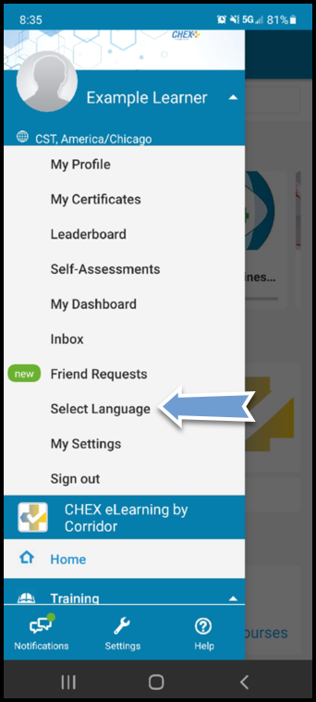
Select Language – This link allows you to set different languages for your app

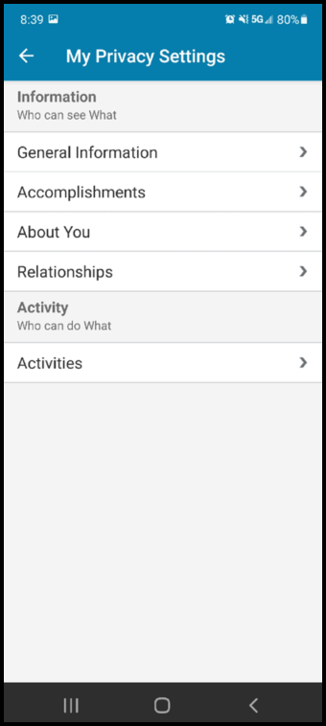
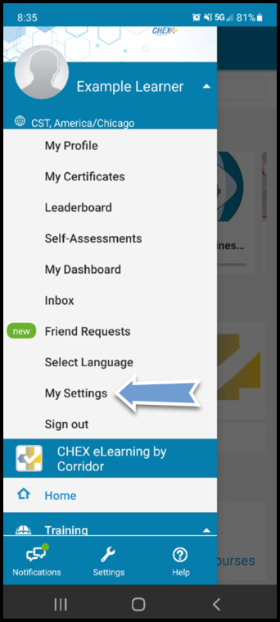
My Settings – this link allows to view and change your privacy settings on the account
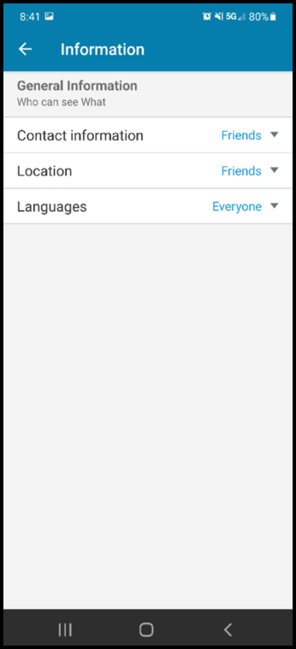
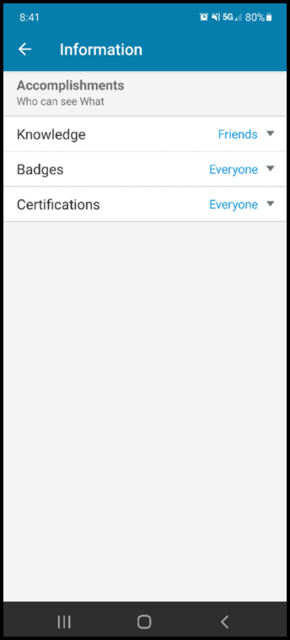
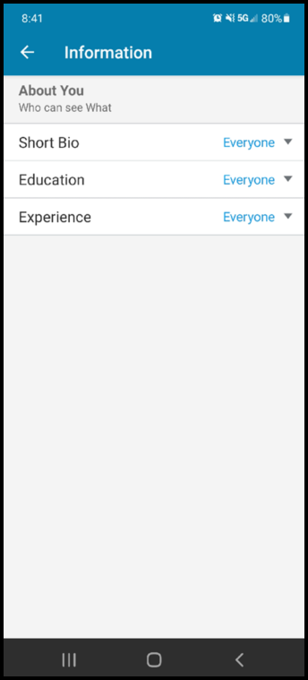

Sign out – this link allows you to sign out of your account
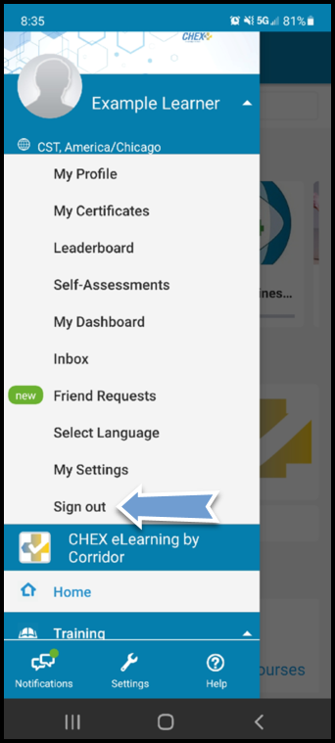

Training
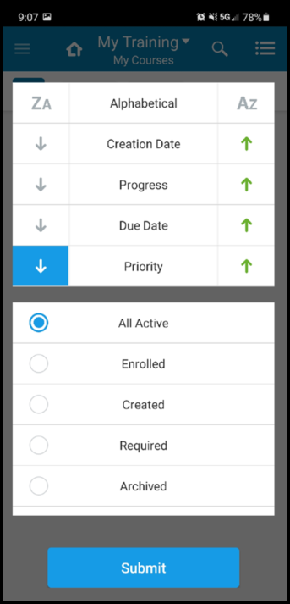
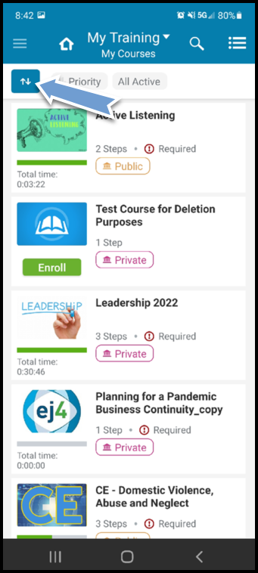
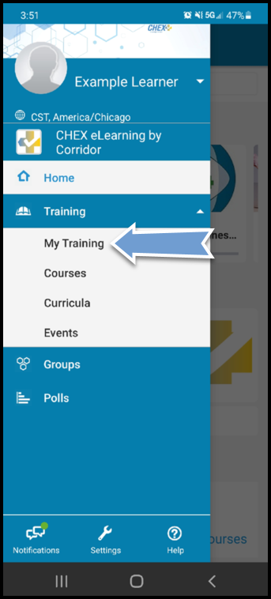
My Training – This link allows learners to view and filter a list of all available modules either through a keyword search, category selection or full list view

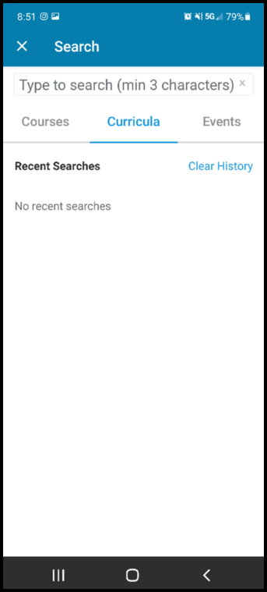
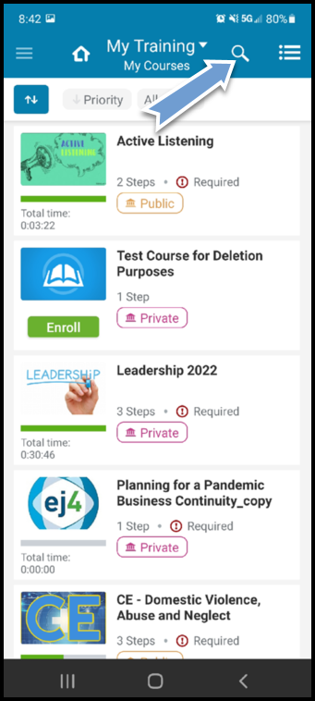

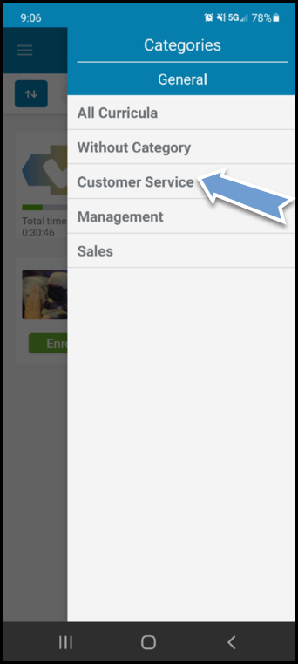
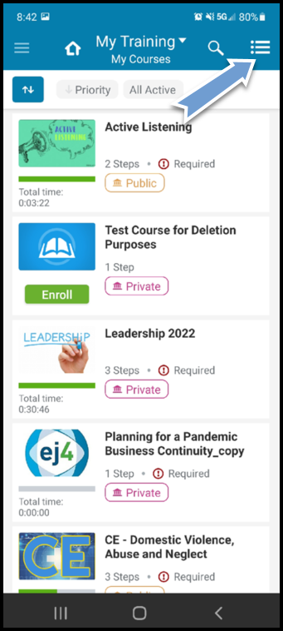

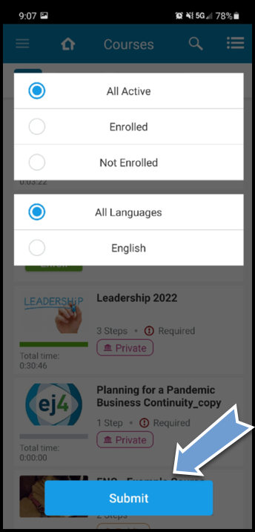
Courses – This link allows learners to view all available, in progress and completed courses
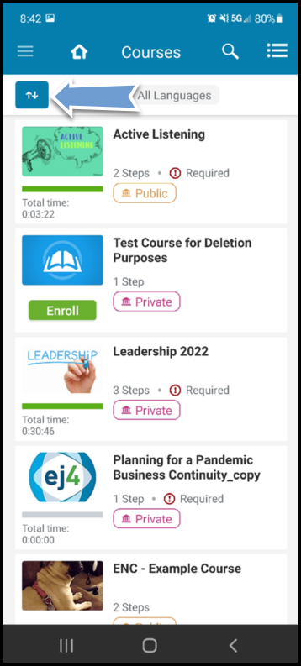
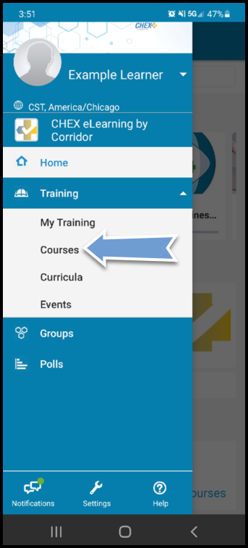

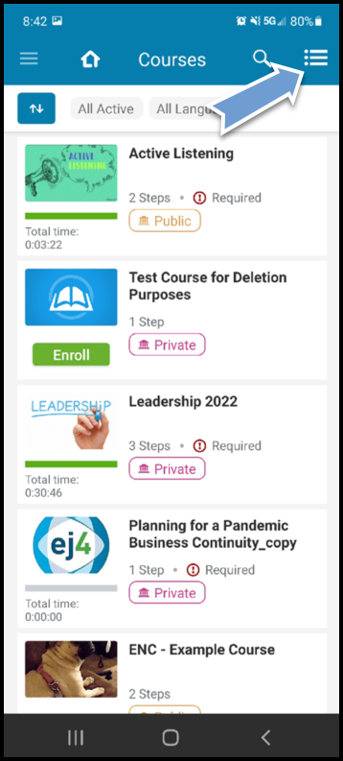
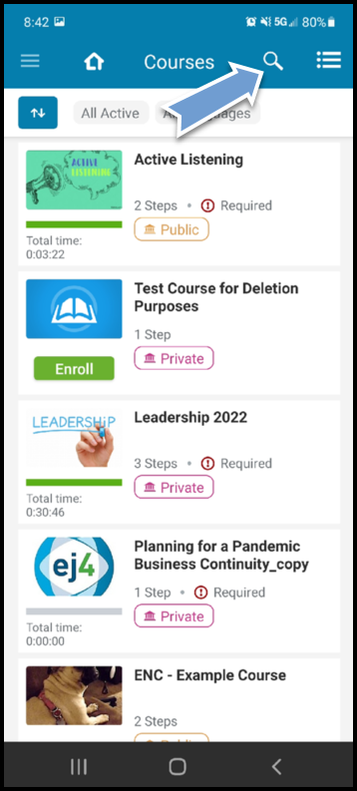

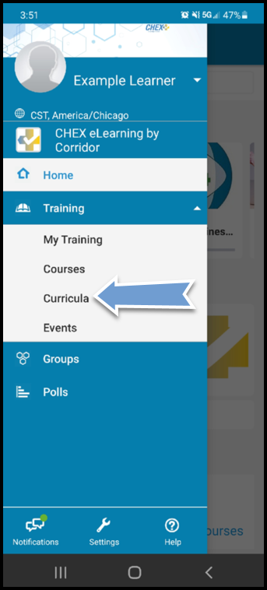
Curricula – This link allows learners to view all available, in progress and completed curricula
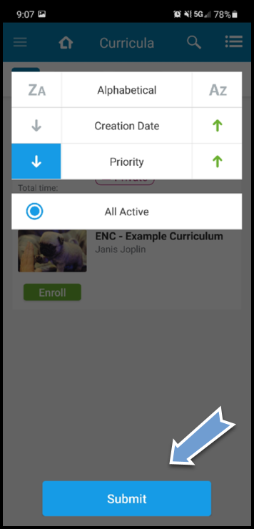
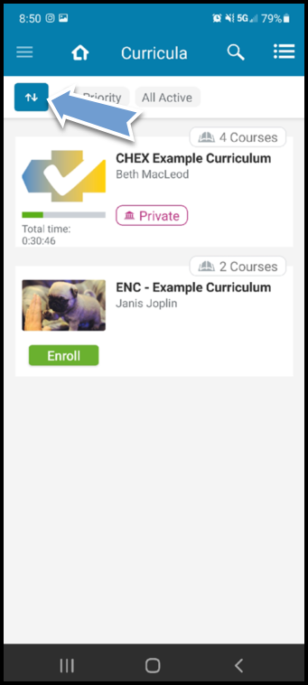

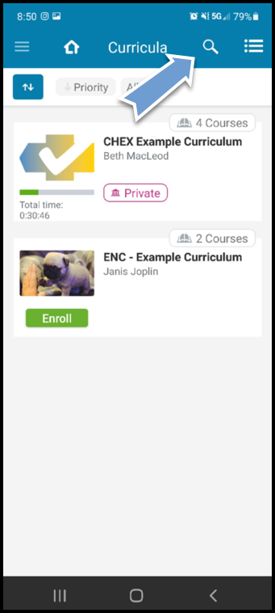

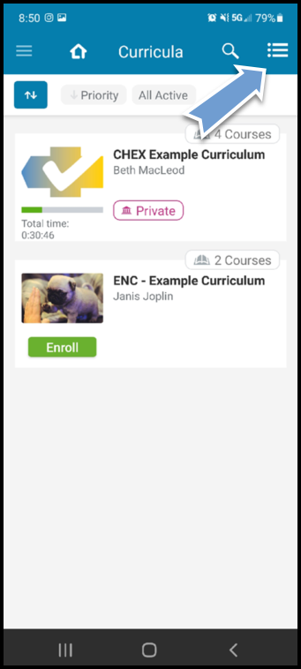

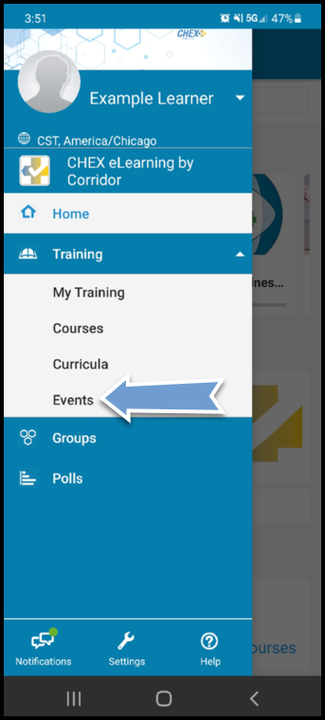
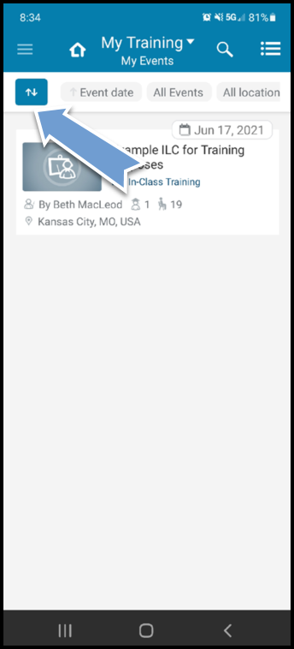
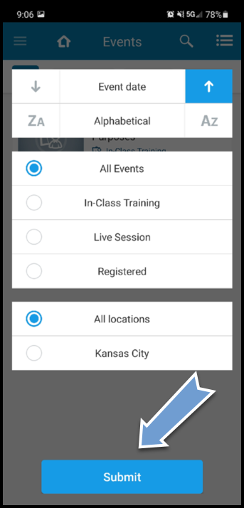
Events – This link allows learners to view all available, upcoming and completed Events

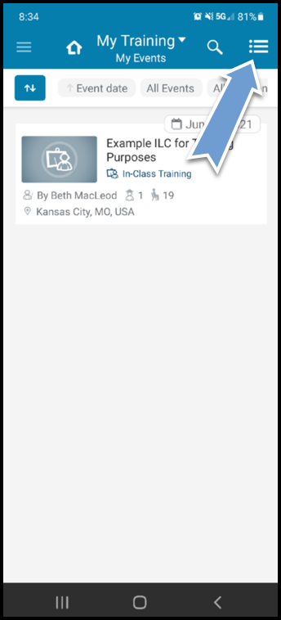
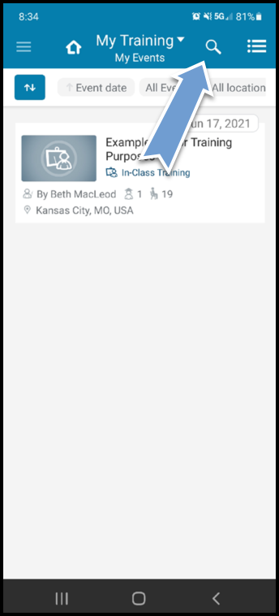

Group
Groups – This link allows you to view all groups you are a member of or available to join
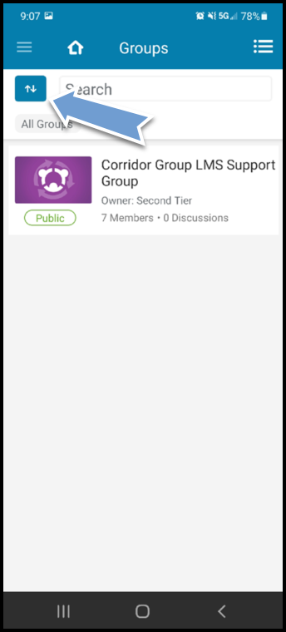
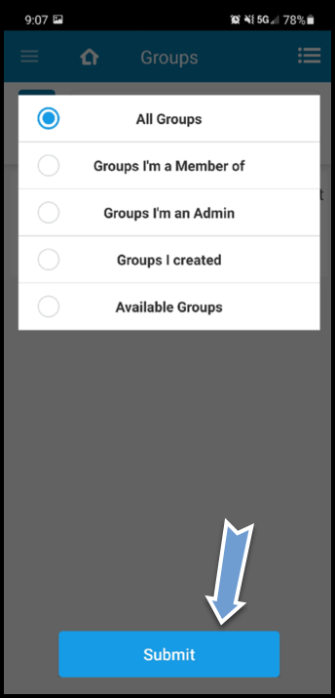
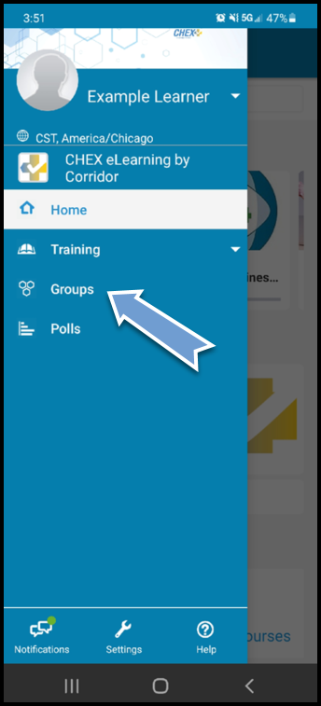

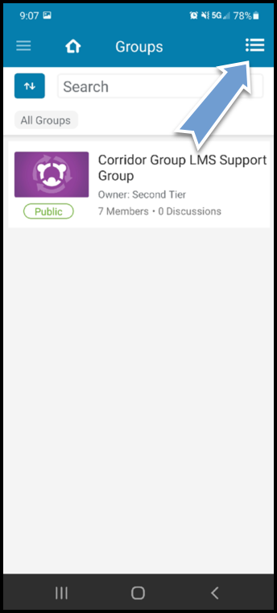

Taking a Course Review and Test from Training Tab
Learners are required to complete the course review and pass the test with a score of 80% or higher. If a learner attempts to skip the course review and moves straight to the test, the learner will not receive credit for the course review and the overall course will remain In Progress.

- Click on the link for the menu (3 horizontal lines)
- Click the Training dropdown
- Click My Training
- Click the course name hyperlink
**Click the green Enroll button first if you are not registered yet
- Click the > at the far right of each lecture
**This will need to be completed for each lecture within the course for successful completion
- Watch the video or review the material in its entirety, then click the back (left arrow) at the top left of the window
**The progress bar will turn green, and show completed once the step has been successfully completed
- Complete steps 5 and 6 for all remaining lecture steps
**You can also click Continue to Step # at the bottom of the page to move to the next lecture
- For exams, click into the lecture and click the green Start button at the top
- Answer all questions and click the Submit or Submit Answer button for each question
- After answering all questions, click the blue Submit Exam button
- Click View Results to review the test questions and answers
- Click the back (left arrow) at the top left or Done after completing the exam with a passing score
- To review the material after successful completion, click Retake and repeat the above process

- Click on the link for the menu (3 horizontal lines)

- Click the Training dropdown

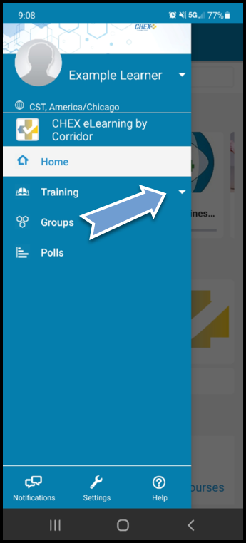

- Click My Training

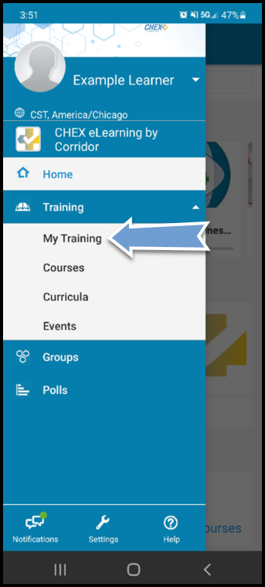

- Click the course name hyperlink
** Click the green Enroll button first if you are not registered yet
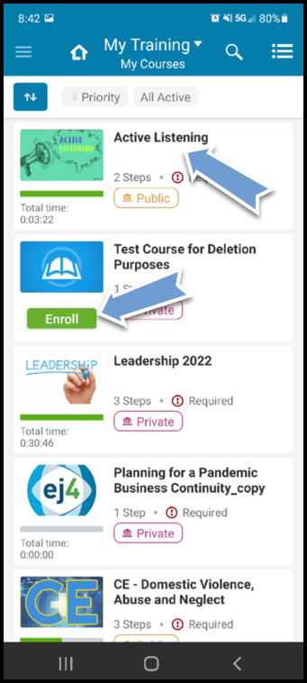

- Click the > at the far right of each lecture
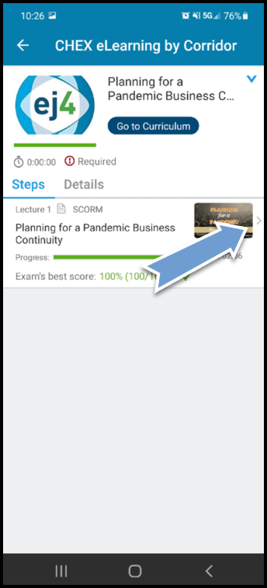
** This will need to be completed for each lecture within the course for successful completion

- Watch the video or review the material in its entirety, then click the back (left arrow) at the top left of the window
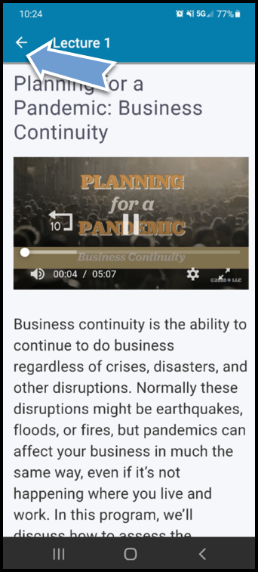
**The progress bar will turn green, and show completed once the step has been successfully completed

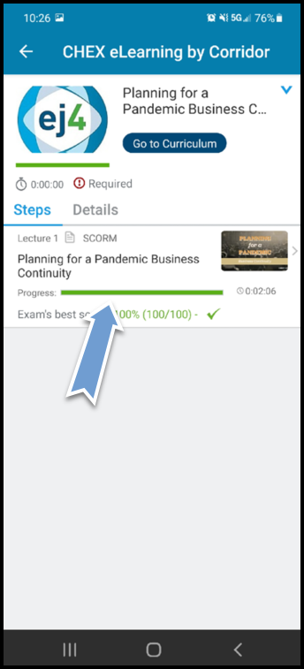

- Complete steps 5 and 6 for all remaining lecture steps
**You can also click Continue to Step # at the bottom of the page to move to the next lecture
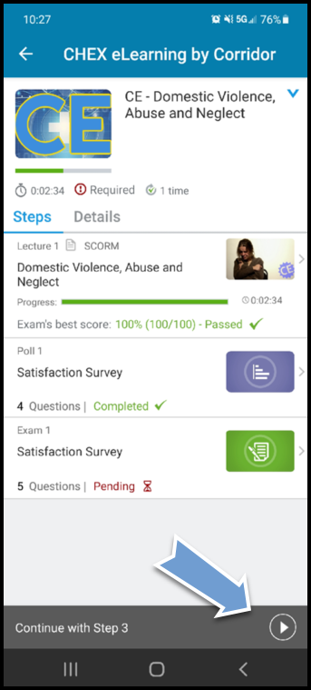

- For exams, click into the lecture and click the Start or Take Exam button
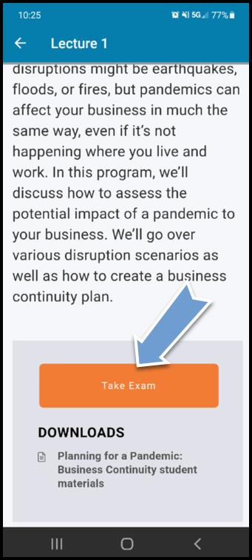

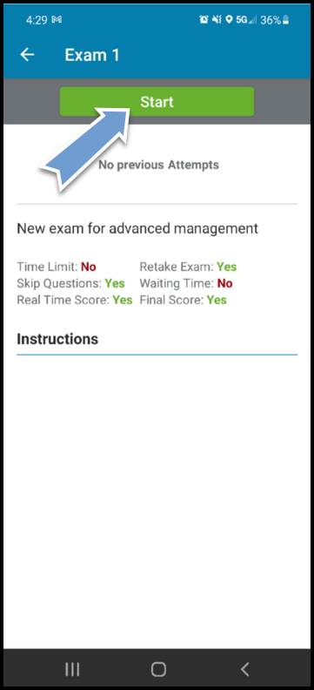

- Answer all questions and click the Submit or Submit Answer button for each question then click Next
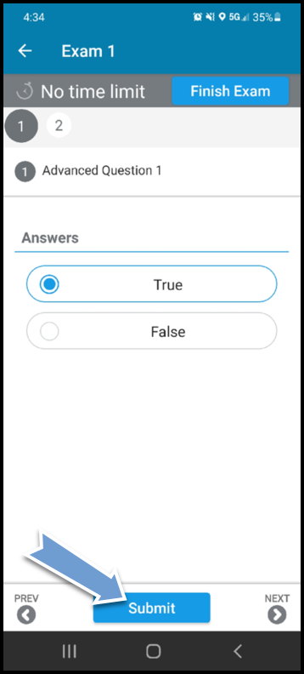
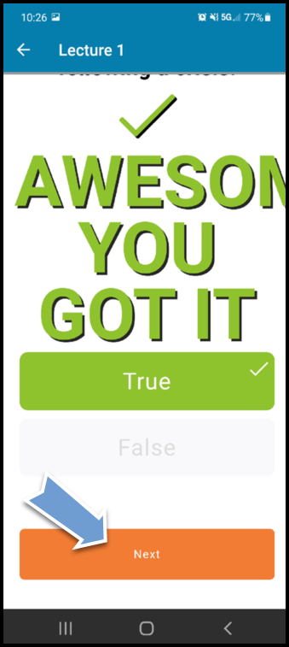
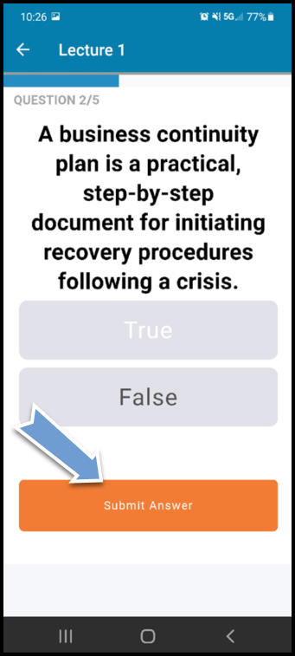

- Click Submit Exam and then View Results to review the test questions and answers

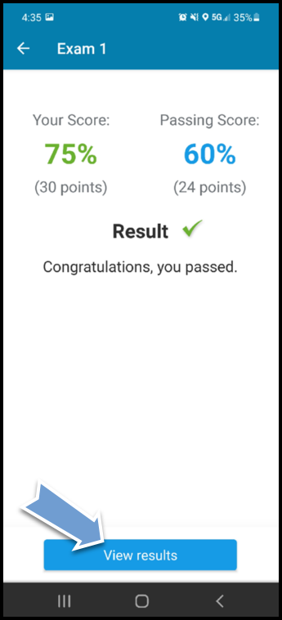

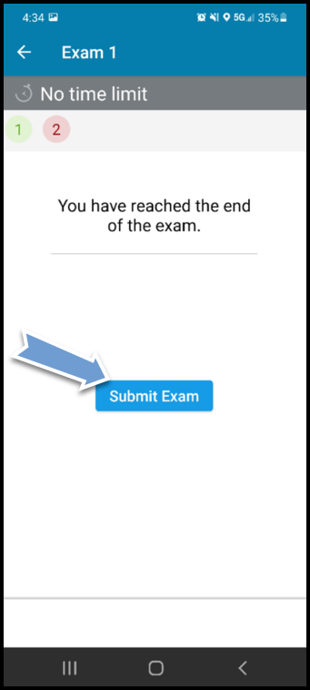

- Click the back (left arrow) at the top left or Done after completing the exam with a passing score
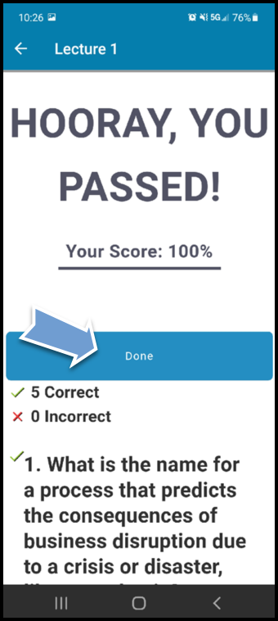
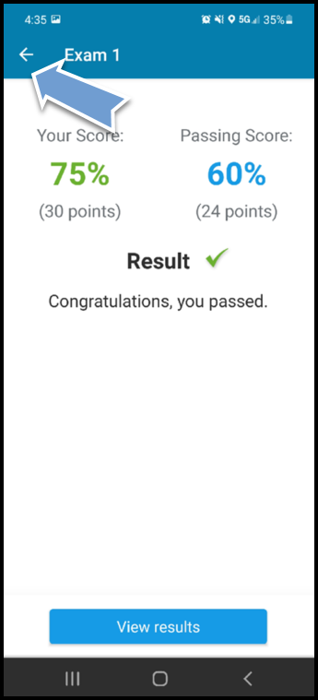

- To review the material after successful completion, click Retake and repeat the above process

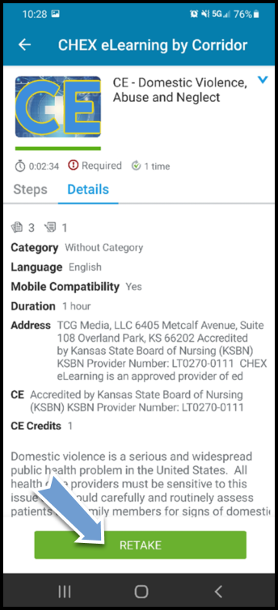

Continuing Education Modules

Modules that offer continuing education (CE) credits upon completion also have a survey that must be completed. Corridor is accredited through Kansas State Board of Nursing (KSBN) to award CEs on approved modules. KSBN requires each user who completes a CE module to also complete a survey. When the course review and test for the CE module have been completed, the user will have to complete a brief survey. After the survey has been completed, the module will be marked complete, and the user will be able to print the CE certificate.

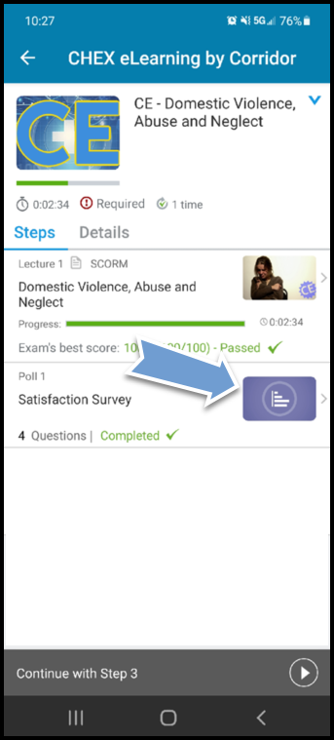
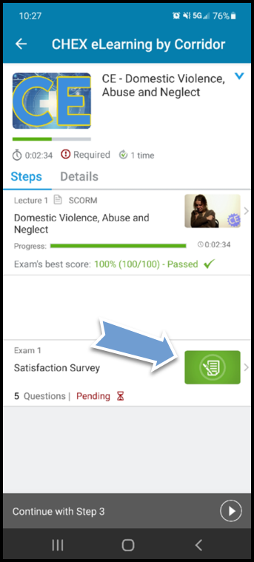

Determine which to keep after deciding on a poll or exam

Curricula
A curricula will contain any number of courses that management deems mandatory and will require you to complete these courses usually in a set number of days or by a given due date.

- Click on the link for the menu (3 horizontal lines)
- Click the Training dropdown
- Click Curricula
- Click the Curricula name hyperlink
**Click the green Enroll button first if you are not registered yet
- Complete each course/lecture within the curricula by clicking the course name
**the system will allow you to freely navigate through the steps, unless a required order is requested by your organization, or the material content requires it
- Follow the steps shown above in the Taking a Course Review and Test from Training Tab section for how to complete the individual courses within the Curricula

- Click on the link for the menu (3 horizontal lines)

- Click the Training dropdown

- Click Curricula
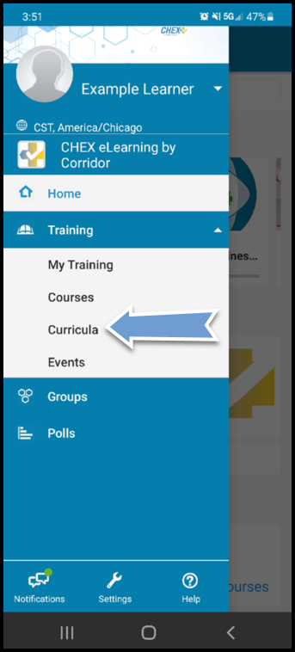

- Click the Curricula name hyperlink
**Click the green Enroll button first if you are not registered yet

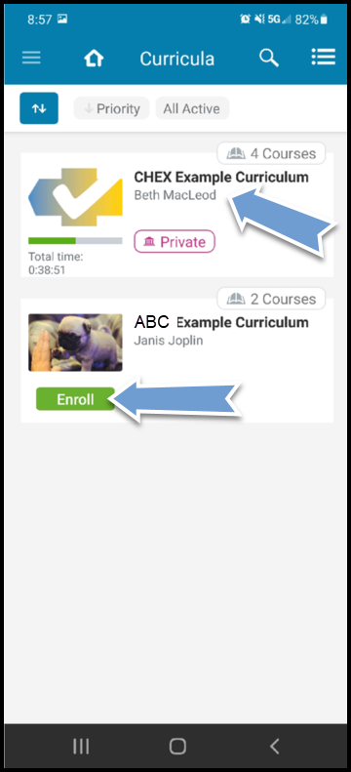

- Follow the steps shown above in the Taking a Course Review and Test from Training Tab section for how to complete the individual courses within the Curricula
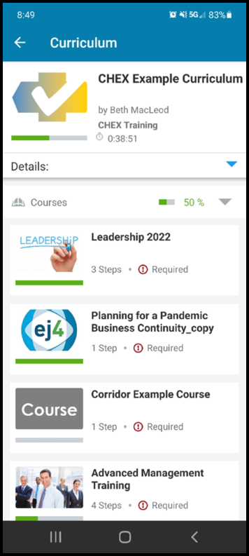

Printing Completion Certificates

- Click Menu (3 horizontal lines) on any screen within the app
- Click the dropdown arrow to the right of your name
- Click My Certificates
- Click the certificate image or View More
- Click the desired course/curricula certificate you would like to print
- Click Allow when prompted on the notice to allow Schoox to access your photos/media
- You will receive a phone notification letting you know that your certificate download is complete. Click that notification to open the certificate image
- The certificate image will open and allow you to save, send, print or open

- Click Menu (3 horizontal lines) on any screen within the app

- Click the dropdown arrow to the right of your name

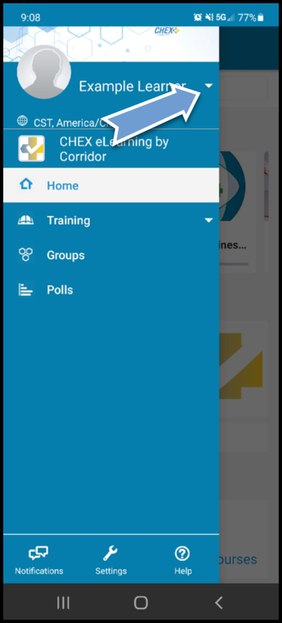

3. Click My Certificates

- Click the certificate image or View More

- Click the desired course/curricula certificate you would like to print

- Click Allow when prompted on the notice to allow Schoox to access your photos/media

- You will receive a phone notification letting you know that your certificate download is complete. Click that notification to open the certificate image

- The certificate image will open and allow you to save, send, print or open

CHEX eLearning Technical Specifications
System Requirements
All software and browsers listed below must be the most current versions.
Minimum Hardware Platform | The minimum hardware requirements are Pentium II 266mhz processor with 2 GB of RAM. The application is optimized for a 1024x768 screen resolution but will work on larger/smaller screens. Java is required to be installed on the client PC.
Supported Browsers | - The most current versions of the following browsers: Chrome, Edge, Firefox, IE, and Safari. For Android devices, you may need to install an older version of the Chrome app due to video playback issues. Until further notice, we’d recommend that you download v.68 or v.69 Chrome app for Android devices. To find one of the older versions of the Chrome app, run a Google search and look for a source you trust.  - Chrome, Edge, Firefox, IE, and Safari may require you to install additional extensions not listed above due to the device configuration. These extensions may be needed to play multiple types of media.  - To ensure optimal performance when using IE, please add the site URL to the list of trusted sites in your browser.  - Pop-up window disabler software must be disabled.  - A standard Web browser with an up-to-date Adobe Flash Player plug-in is sufficient. The Flash player plug-in is standard on most browsers, so users won’t have to download an additional plug-in. Depending on the type of content uploaded to CHEX, the users might require additional software to be able to view the content (ex. Microsoft Word for Word documents, a media player for movies).
Supported Mobile Devices | iOS 4+  Android 3+  Blackberry OS 6+  Windows Phone 7.5+
Browser  Plug-Ins | Depending on your eLearning courses and the material you place in the portal areas, your end-users will likely need other common internet plug-ins. Most of these plug-ins are standard and already installed on computers.  - Flash (requirement on desktops but not mobile technologies)  - Adobe Viewer (PDF)  - Microsoft’s Media Player  - Java
Disable Browser Pop-Up Blocker Instructions
Chrome | https://support.google.com/chrome/answer/95472?hl=en
Edge | https://www.techieshelp.com/microsoft-edge-disable-pop-up-blocker/
Firefox | https://support.mozilla.org/en-US/kb/pop-blocker-settings-exceptions-troubleshooting
IE | http://windows.microsoft.com/en-us/internet-explorer/ie-security-privacy-settings#ie=ie-11
Safari | https://support.apple.com/kb/PH19284?locale=en_US&viewlocale=en_US

